(Approx. 646 words)

Protect Your Computer Against Power Outages
By Matt Batt, Past President, The Computer Club
www.scccomputerclub.org
mattbatt (at) gmail.com

The two main causes of damage to computers, TVs, modems, and other sensitive electronics are a sudden loss of power and power fluctuations. Basic power strips do not protect your PC from any sort of electrical fluctuations; surge protectors can protect against power surges, but they offer no protection against drops in line voltage or loss of power.

To protect your computer against power outages or voltage fluctuations, you need a battery backup. UPS (Uninterruptible Power Supply) units are basically surge protectors that contain a battery inside. In the event of a power failure, your computer will seamlessly switch over to battery power and continue to run. This gives you time to shut down your machine without any damage.

Many UPS units come with software that can detect when the unit switches to battery power and shut down automatically in your absence.

There are many di8fferent UPS offerings on the market. There are small units that can keep a desktop computer running for 5-10 minutes or longer, more expensive units that can keep multiple computers running for hours.

The most important step in choosing a UPS is to buy one that has enough power to give your computer system enough time to shut down properly. While it is possible to calculate the power usage of a computer system by analyzing all of its components, for purposes of this article we can estimate the requirements of a typical computer user in our club.

UPS systems are rated VA (Volt-Amperes). Ignore how it is calculated, but a typical low-end desktop needs a UPS rated at about 480 VA while a high-end computer with a high-end video card would need a UPS rated as high as 1200=1500 VA.

Two types of UPS units have an application to home electronic systems.

The least expensive is a Standby UPS. This type of unit charges its battery and waits. When the power cuts off it will automatically switch to the battery for backup power. The switch takes milliseconds and is fast enough so that most electronics do not shut down.

For a higher cost, you can get a unit with Automatic Voltage Regulation (AVT) that corrects power fluctuations without switching to battery power. This feature protects you from instabilities in line voltage often experienced in lightning storms.

There are a few other considerations to note;

Some units include software for your computer that senses when the UPS switches over to battery power and can automatically initiate the shutdown process.

UPS units generally have a mix of power/surge protected and surge protected only outlets. Make sure that there are enough outlets for your needs.

Some UPS units include surge-protected/filtered ports for your Ethernet and Coax cables. Personally, I don’t use these as I’ve had problems with ethernet cable performance degrading through a UPS.

Be sure to get units that have user-replaceable batteries. UPS batteries last 3-5 years. When a battery fails, you’ll either need to buy batteries or but a whole new unit.

I’ve used Cyberpower and APC UPS units and they all worked as advertised. The two pictured below from Amazon both have shutdown software and replaceable batteries. The APC is rated at 500VA and costs $55.00. It has 5 outlets with Battery backup and two with just Surge protection. It’s the model I use on most of my computers and TVs. The Cyberpower has AVR, is rated at 1000VA, and costs $109.00. It has 5 outlets with Battery backup and four with just Surge protection. I use one like it for my main computer, Internet mode, router, and my phone system.

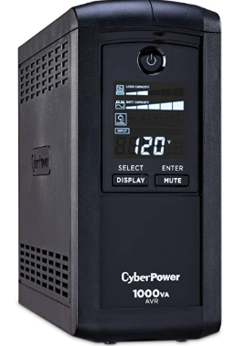
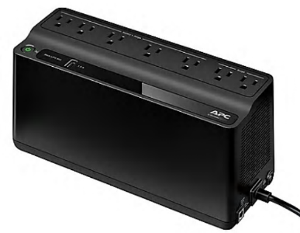

Be careful out there! Think about having a UPS system on your computers, TV, home theater system, and even your phone system to prevent damage caused by power surges and power loss.

